Project Design Phase-II
Technology Stack (Architecture & Stack)
Date | 21 October 2026
Team ID
Project Name | Incident Lifecycle Management System in ServiceNow
Maximum Marks | 4 Marks
Technical Architecture:
Every incident moves through four stages (create, assign, resolve, close) on one ServiceNow cloud instance.
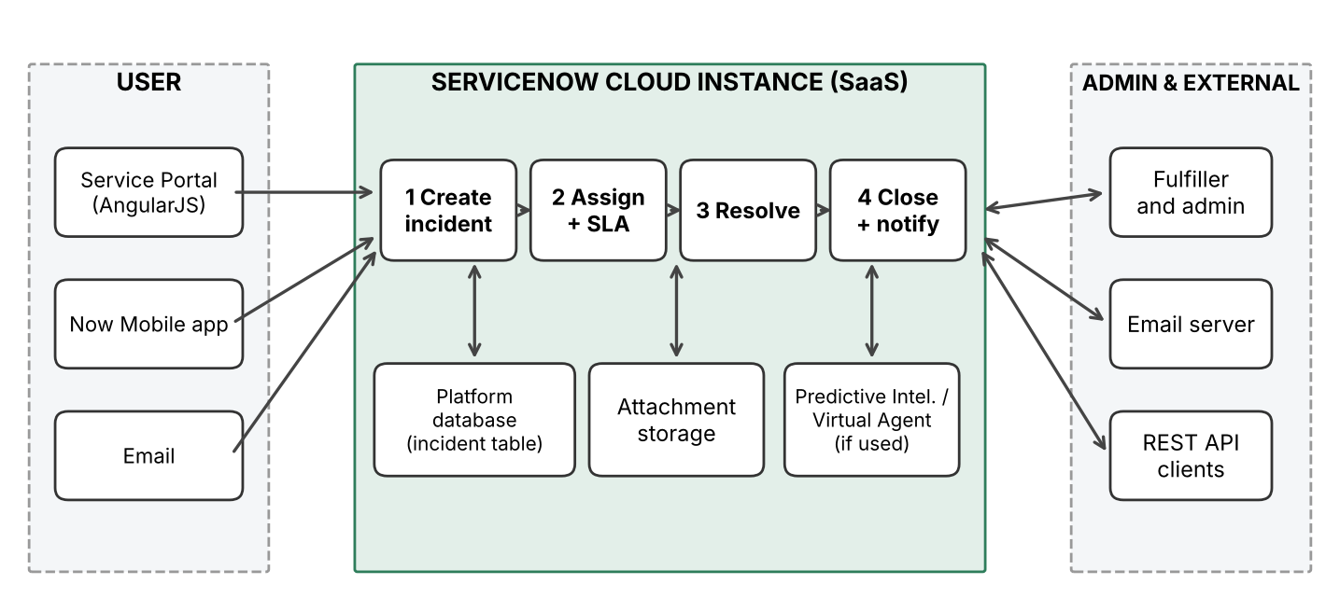
Table-1: Components & Technologies:
S.No | Component | Description | Technology
1 | User Interface | Web portal and mobile app where users raise and track incidents | ServiceNow Service Portal (HTML, CSS, JavaScript, AngularJS), Now Mobile app
2 | Application Logic-1 | Incident creation: validation, defaulting and form behaviour | Business Rules, Client Scripts, UI Policies
3 | Application Logic-2 | Assignment and escalation: routing to groups, SLA tracking | Assignment Rules, SLA Definitions, Flow Designer, Workflow
4 | Application Logic-3 | Resolution and closure: state changes, notifications, auto-close | Flow Designer, Notifications, Scheduled Jobs
5 | Database | Incident data stored in relational tables (incident extends task), configurations | ServiceNow platform relational database
6 | Cloud Database | Database service hosted on the cloud instance | ServiceNow cloud instance database (Personal Developer Instance)
7 | File Storage | Attachments (screenshots, logs) on incident records | ServiceNow attachment storage (sys_attachment)
8 | External API-1 | Create/update incidents from email and send email notifications | Inbound Email Actions, SMTP/IMAP
9 | External API-2 | Integrate third-party systems with incident data | REST API / REST Message (JSON)
10 | Machine Learning Model | Auto-categorise/route incidents and answer common queries (if used in project) | Predictive Intelligence, Virtual Agent
11 | Infrastructure (Server / Cloud) | Application deployment on Cloud. Local Server Configuration: not required. Cloud Server Configuration: ServiceNow-hosted instance | ServiceNow cloud instance (SaaS)

Table-2: Application Characteristics:
S.No | Characteristics | Description | Technology
1 | Open-Source Frameworks | Open-source front-end frameworks used in the portal | AngularJS, Bootstrap, jQuery
2 | Security Implementations | Access control, authentication, encryption and auditing | ACLs, roles/groups, HTTPS/TLS, SSO (SAML) and MFA, audit/history logs
3 | Scalable Architecture | Three-tier cloud architecture: presentation, application, database | ServiceNow multi-tier cloud architecture
4 | Availability | Data-center replication, failover and managed backups | ServiceNow cloud infrastructure
5 | Performance | Indexing, caching, scheduled jobs and asynchronous business rules | DB indexing, platform caching, scheduled jobs, async business rules

